Báo cáo Lab 05

Họ và tên: Nguyễn Huy Hoàng

MSSV: 20225845

1. Swing components:

Swing Accumulator

AWT Accumulator

1. Organizing Swing components with Layout Managers:

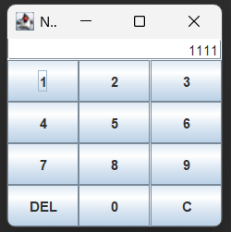

Number Grid

After DEL

After C

1. Create a graphical user interface for AIMS with Swing

Store GUI

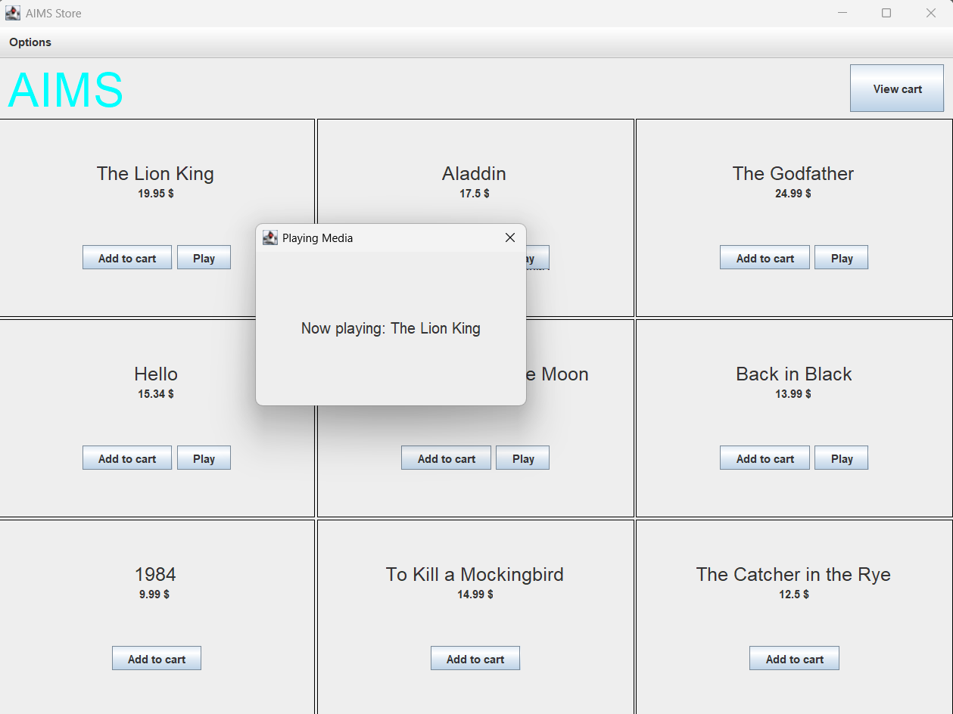

When clicked Play

When clicked Add to cart

1. JavaFX API

Paint

5-15.

